Division Annual Report 2023
This Division Annual Report form has been developed to help the Division Relations Committee and CEC identify new division projects and initiatives and monitor division needs. Our goal is to champion and support CEC divisions and this report will help in achieving that.
Division Name: Division of International Special Education and Services (DISES)
Officers:
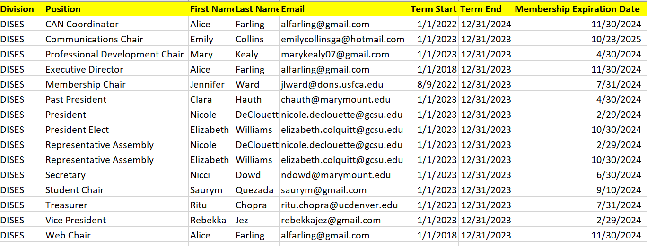
*Division Mission:
The Division of International Special Education and Services (DISES), a division of the Council for Exceptional Children, promotes knowledge exchange, collaboration, human rights, and advocacy to those who provide services for individuals with disabilities.
Description of Division:
DISES focuses on global special education programs and services. Members receive the Journal of International Special Needs Education and access to DISES Virtual Events and Information Briefs, Member Spotlights, and informal Sip & Chats.
Membership Numbers Overview:
December 2023 | 361
Oct 31 2023 | 348
Dec 31 2021 | 407
Dec 31 2018 | 400
Dec 31 2016 | 455
*Completed By: Nicole M. DeClouette (President 2023), Alice Farling (Executive Director)
When does your fiscal year end? December 2023

CEC Strategic Goals
CEC Goal: Develop and support an effective and diverse workforce of special education professionals. Activities of Division:
1. DISES & DEBH Virtual Event “Mental Health & Schools: International Webinar Panel” was held September 30, 2023. Presenters included: Dr. Tim Landrum (University of Louisville), Dr. Gabriela A. Rangel-Rodriguez (Universitat Autonoma de Barcelona), Dr. Mervat Haris (University of Jordan), Dr. David Royer (University of Louisville).
2. DISES presented at the CEC Professional Development Fair on September 28, 2023. The title of the presentation was “Preparing Globally Competent Pre-Service Special Education Teachers.” Presenters were DISES leaders: Dr. Clara Hauth, Dr. Rebbeka Jez, Dr. Nicole DeClouette, Dr. Nicco Dowd, Ms. Tanya Pinkerton.
CEC Goal: Intentionally embed diversity, equity, inclusivity, and accessibility within CEC. Activities of Division:
1. Sip & Chats hosted by DISES foster inclusivity and belonging:
- March 25
- April 29 (focus on student members)
- July 22, 2023 (focus on transition)
- August 5
- November 4
- December 9 (focus on families)
2. DISES Student Representative, Saurym Quezada, created Two New Student Groups:
- DISES Student Virtual Community Group. The virtual group will provide a space to share general announcements, celebration of personal and academic milestones, networking, and an overall connection through the academic year. Saurym says, “I hope this initiative will allow us to create community within DISES and help us develop new professional collaborative relationships and perhaps friendships.”
- Monthly Writing Accountability and Networking. The purpose of these meetings is to hold intentional “check ins” for students who are engaged in research and writing. The meetings are scheduled for Thursdays at 5:00pm (Eastern Time), and the first meeting with be September 29th.
CEC Goal: Increase the impact of CEC’s policy agenda for education professionals and for individuals with disabilities and/or gifts and talents. Activities of Division:
1. Dr. Nicci Dowd attended the CEC Leadership activities in VA in July on behalf of DISES. Dr. Dowd is the DISES Secretary.
2. DISES member, Dr. Jugnu Agrawal, serves on the Divisions Relations Committee.
3. DISES Executive Committee members Dr. Nicole DeClouette and Dr. Rebekka Jez served on the Interdivisional Collaborative.
CEC Goal: Establish CEC as a globally recognized leader in the field of special education. Activities of Division:
1. DISES Member Spotlights, written by Past DISES President, Dr. Mary Kealy.
- Dr. Ritu Chopra (December 2023). Dr. Chopra is the Executive Director of the Paraprofessional Resource and Research Center at the University of Colorado. Dr. Chopra and her family developed and manage Project Sambhav within Deepalaya in poor communities in urban and rural areas around New Delhi, India. Project Sambhav offers services such as education and vocational training for women, children and youth, and health initiatives.
- Dr. Nicci Dowd (July 2023). Dr. Dowd is an Assistant Professor of Special Education at Marymount University, Arlington VA. Dr. Dowd has worked with stakeholders in Uganda, Panama, and Colombia to promote interculturalism and to foster inclusive practices.
- Dr. Ashley Molloy (April 2023). Dr. Molloy teaches at Niagara University in Ontario. Dr. Molloy has presented and consulted in over 20 countries.
- Dr. Aleksandra Ristic (February 2023). Dr. Ristic is a special education teacher in a primary school in Slovenia. She is passionate about empowering students with disabilities and providing support and mentoring to classroom teachers and other school personnel.
2. DISES Information Briefs Published:
- February 2023: Help and Support for At-Promise Learners’ Academic and Emotional Well-Being: Moving the 2022 UNESCO Report to Inform Inclusive Practices in our Communities.
- April 2023: Forum on Inclusive Practices: Africa, Europe, and the Caribbean
3. Journal of International Special Needs Education (JISNE) publication:
- September 2023: Volume 26, Issue 1. Articles in this issue included:
  - Teacher Attitudes and Perceptions of Inclusive Education: A Case of Ghana
Jonathan Chitiyo, Gordon Brobbey, Kwame Bediako Asare
  - The Efficacy of the Current ADHD Training Programs in Saudi General Education Elementary Schools: A Systematic Review
Laila Abdulwahab Aljumah, Fatimah Abdullah Alhaddad
  - How Pedagogues Support Inclusion in Denmark: Experiences, Barriers, and Recommendations
Cristina Gulløv, Wendy W Murawski
  - Conversations with Panamanian Parents Regarding Their Children with Disabilities
Naima Bhana Lopez, Ph.D., Gabriela A. Rangel-Rodríguez, Ph.D., Tracy J. Raulston, Ph.D.
  - Korean American Children with Disabilities and Their At-Home Distance Learning During the COVID-19 Pandemic: Findings from a Survey of Parents
Sung Hee Lee, Adrian Woo Jung
Activities of the Division. Provide the top activities and accomplishments of your division during the previous year.
1. DISES 2023 International Roundtable in Bangalore, India (held July 12-14, 2023)
2. DISES 2024 International Conference in Panama City, Panama (will be held June 26-28, 2024). Planning for this event started in May 2023.
3. CEC Interdivisional Grant $8000 (led by Dr. Rebekka Jez) with the Division of Career Development and Transition (DCDT), the Division of Early Childhood (DEC), and the Division of Visual and Performing Arts Education (DARTS). The purpose is to create an innovative, cross-divisional video podcast series to foster critical global conversations that support youth, families, and educators in culturally responsive and sustaining practices during and beyond the birth-to-20 experience. The collaborative series will not only acknowledge the great work being done across CEC divisions, but will amplify the gifts and practices of learners, families, and educators at the local, national, and global level.
Top Areas of Support
Please use this space to provide a list of up to three top concerns of the Division. The purpose of this question is to reveal areas for collaboration about best practices among divisions, or to highlight areas where the division might desire further support from DRC and/or CEC.
- Make CEC and DISES memberships affordable for international members
Upcoming Goals
Please use this space to provide your upcoming goals and presidential priorities of your division. Please note you do not need to complete all the fields, feel free to leave blank. Please indicate any division partnerships as well.
1. Highlight culturally responsive and sustaining inclusive practices across the globe. As an organization, DISES aims to “promote knowledge exchange, collaboration, human rights, and advocacy” across the globe.
2. Increase cross-divisional engagement
3. Increase membership engagement across the globe
4. Implement a successful international conference in Panama (July 2024)

