
DISES Annual Report 2024
Prepared by: Rebekka Jez (President 2024)
Date: 12-31-2024
The Division of International Special Education and Services (DISES), a division of the Council for Exceptional Children, promotes knowledge exchange, collaboration, human rights and advocacy to those who provide services for individuals with disabilities.
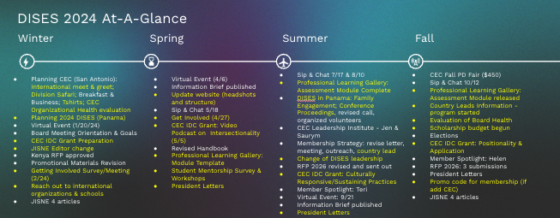
DISES Highlights and Accomplishments:
2 Virtual Events promoting inclusive practices and 2 information briefs w/links to youtube videos published on events
Hosted multiple committees and working groups to DISES members to get involved
Began intentional outreach for donations and sponsorships for members needing financial assistance to attend conferences (scholarship budget)
IDC Grant funded Critical Conversations Video Podcast Series (intersectionality, positionality, practices, and praxis to promote living and learning)
Highlighted professionals around the world with awards, 2 member spotlights, and president letters
Updated membership outreach including beginning a program for DISES Country Leads to increase outreach globally.
Publish 2 volumes of the journal with 4 articles in each volume.
Hosted DISES sponsored student engagement events for graduate students and teachers
Lead 3 CEC Fall PD Fair presentations
Created the Professional Learning Gallery committee to promote global knowledge and impact. Created a module template, completed Assessment module and 8 other modules in development. Applied for IDC grant to assist with completion and improvement.
Increased connections to international schools and educational programs around the world
Hosted 4 Sip & Chats to provide a discussion space for current and potential members from around the globe.
DISES, DCDT, DEC, and DARTS IDC funded video podcast series to foster critical global conversations that support culturally responsive and sustaining
Professional Learning Gallery for educators and families to have access to information about culturally responsive and sustaining inclusive practices
Successful DISES conference in Panama City, Panama. First ever conference proceeding published from selected conference papers.
Increased member engagement in committees: membership, sip & chat, virtual events, professional learning gallery, student engagement, family engagement
DISES Panama Conference (06-26-2024), Panama City, Panama
Attendees: approximately 150
The DISES International Conference in Panama, Global Education: Equity and Inclusion for All, was absolutely amazing. We truly saw the embodiment of radical inclusive education for all during the conference. The care, conversations, community, excursions, exploration, love, compassion, service, support, collaboration, and intersectionality were so apparent over the three days of the conference–and that was because of all who attended. A special thanks to our planning co-chairs, Dr. Clara Hauth and Senora Maria Virginia Paredes. If you want to check out some of the photos from the conference, check out the DISES Panama Conference video. Check out the 2024 DISES Conference Proceedings on the DISES website.
Learning About Inclusive Education in the Global Context: Voices from the Field
Virtual Event and Information Brief 2024-04-06
Attendees: 25
Zhang, D., Lane, D., & Jez, R. J. (2024). Learning About Inclusive Education in the Global Context: Voices from the Field. Division of International Special Education Information Brief, 1-4.
Interdivisional Video Podcast Series on Global Conversations: Supporting Youth, Families & Educators in Culturally Responsive and Sustaining Practices Virtual Gallery
Link to Critical Global Conversations
Future DISES Events
DISES Conference in Kenya July 1-4, 2025
DISES Country Leads program
Sip & Chats
Virtual Events and Information Briefs
DISES Board Topics:
DISES is a division that is well situated to promote global interaction for CEC as a whole and we have enthusiastic members and many global contacts for this work to be done. We had many conversations this year about what being an elected volunteer at a non-profit organization means for compensation of travel costs (flight & hotel) and registration for board members (especially with our international conference cost). Our budget was a huge topic of conversation for the board this year. At our last full board meeting we discussed the following topics:
*Continuing to increase CEC members involvement in DISES
*how we support our board members' involvement in conferences. For example, we pay for both CEC and DISES conference registration and travel costs which can be very expensive. At the DISES conference we all volunteer our time at the registration desk, presentation rooms, field visits, etc and are not always able to attend the sessions we hope to. We may benefit from learning more about how other divisions who host conferences are spending their budget.
*the need for more succession planning for the board- many of our elected positions run unopposed or we have lost board members due to unforeseen circumstances and we have needed to appoint people. This may be a result of the high cost of being on the board as well and the expectation that you attend the conferences.

